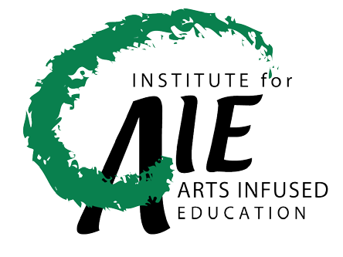 Mixture of Art and Materials

In this unit, students will study the Rock Art of the Anazasi and create their own mixture to produce their own rock art. Students will also demonstrate using geography to interpret the past and plan for the future.

Grade Levels:
3-5

Lesson Overview:
Incorporating the arts-infused curricula of chemistry, geography, and visual arts, teachers and students will be enabled–and inspired– to synthesize and recreate the materials and methods available via this link.

Length of Lesson:
15 mins plus drying

Resources:
Books:
“Native American Rock Art: Messages from the Past”, by Yvette La Pierre
Rock Art by Jan Hillmer
Stories in Stone: Rock Art Pictures by Early Americans, by Caroline Arnold
Websites:
Interpreting Rock Art of the Anasazi
International Rock Art Database
Anasazi Places: Ruins and Rock Art-A Photography Journal
How to Make Colored Chalks

Supplies
- Popsickle stick (one per student)
- 2-cup measure of water
- 1 stick of modeling clay per student (plasticine clay)
- Section of slate or side of brown paper bag
- Handouts on Native American pictograph images (see online resources)
- Small margarine tub of plaster of Paris
- Talc
- Cornstarch
- Food coloring dyes or dry pigment paints
- Empty margarine bowl
Difficulty: Average

Here’s How:
- Combine all ingredients, keeping in mind that the amount of paint used correlates with the intensity of the chalk color.
- Pour the mixture into candy or popsicle molds.
- Let dry.
- Have fun!

Tips:
- Lining molds with waxed paper will make removal of the chalk easier.
- The chalk works best just after it has dried and is removed from the molds.
- Toilet paper tubes or 5-oz disposable cups may be used as molds.
- Acrylic paint may be used instead of tempera, but may not be non-toxic.

Content and Standards:
- SCI IV. 1.E.1, V.1.E.2, V.1.E.5, IV.1.E.1
- VISUAL ARTS II.1, I.3
- GEOGRAPHY Standard 12, and 18
Submitted by Wiley McDowell

