Creative Ideas for Teaching of

the Humanities

There are many good ideas that can be used to infuse the teaching of history, literature, philosophy, and psychology with the arts. Indeed, the possibilities are endless.

Picturing Texts/Text Pictures
Inspired by the aesthetic of concrete poets, students can build pictures of words in which image matches text with sometimes profound results. Here is an eighth grade girl’s text picture treating the bloody French Revolution. The text comes from Will and Ariel Durant’s The Age of Napoleon. Done in colored pencil and pen.
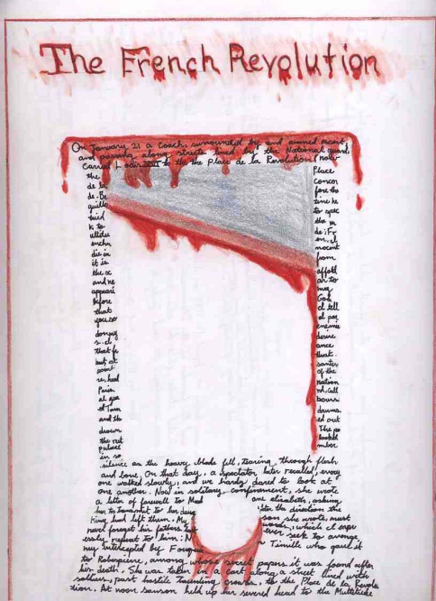

The Illustrated Fact-Sheet
Fact-sheets are fun, economical, and easy projects for students. They can be embellished with illustrations and other kinds of imaginative work. Here is an eighth grader’s fact-sheet on Wolfgang Amadeus Mozart, which includes a thoughtful portrait in profile of the great composer.
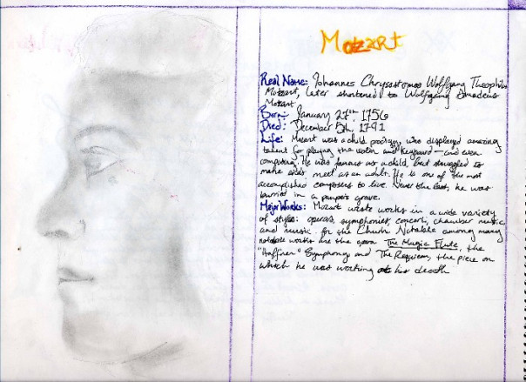

The Illuminated Poem
Students can “illuminate” lyrics, poems, or great works of prose in a manner similar to the medieval Irish monks who gave us the Book of Kells and other great manuscripts. I do not necessarily mean that they should copy the intricate designs of Celtic monastaries and write with a goose quill in unical–though it’s a good idea!–but they can illuminate these words with appropriate and insightful designs of their own in a more contemporary idiom.Here is an example of an eighth grader’s illumination of the Prologue to William Blake’s long poem Milton. It is more popularly known as “Jerusalem.” Its subject is the apocryphal story of the young Jesus traveling to England as a boy with Joseph of Arimathea. It is Blake’s powerful statement of imagination in contrast to the pollution, corruption, and decay he saw in the London of his own day (1805, to be precise). In the early twentieth century, Blake’s words were set to music by Henry Perce. This song is the “unofficial national anthem” of Great Britain, sung at the beginning of every soccer game.
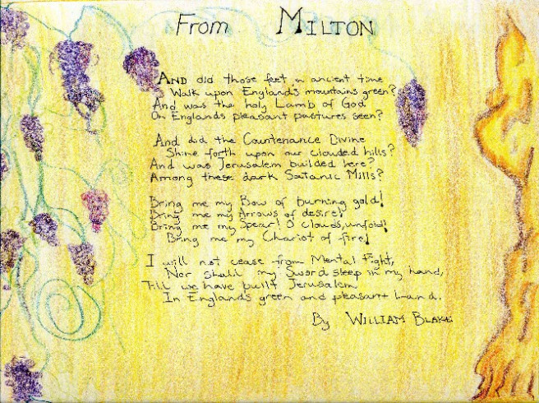

A Tale of Two Cities
Here is an example of a student’s illustration of A Tale of Two Cities. She used techniques familiar to collage and scrap-booking.
