Renaissance Part Two: The Great Artists of the Renaissance
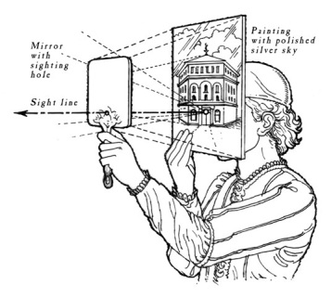
Filippo Brunelleschi is credited with the discovery of linear perspective. As the story goes, he one day was seen in front of St Mark's Cathedral in Florence, looking through some contraption. His activity intrigued some acquaintances who wanted to see what he was up to.
A great way to begin this segment would be with the discovery of linear perspective by Filippo Brunelleschi. This could lead to other interesting elements of the science of art such as the Golden Ratio, the Fibonacci series. As there is such a wealth of information, it may be hard to choose just who to do; so discretion may guide us toward representative figures. Two of the most fascinating, and two who make wonderful contrasts to each other, are Leonardo da Vinci and Michelangelo Buonoratti. These men knew each other, competed with each other, and, at least on Michelangelo’s side, hated each other.
Leonardo, the elder, is a study a of a person in love with ideas. Innovation, invention, and imagination were his hallmarks. However, many of his works were never completed, and some of those he did complete (The Last Supper, for instance) fell to ruin not long after their completion.
Michelangelo, on the other hand, though he left several works incomplete, is a classic example of the over-achiever, a man married to his work. He is also known as a “master of four arts”: painting, sculpture, architecture, and poetry.
There are many other artists one might introduce. Botticelli, Raphael, or others.
In connecting the Golden Ratio and perspective with this unit, it would be of use bringing in works of renaissance art and allowing the students to discover the relationships of design within the works.
Here is a link to help you incorporate math using the Golden Ratio and the Fibonacci series.
Some representative works might include the following:
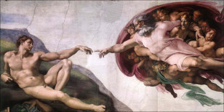
Michelaneglo - Creation of Adam
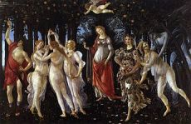
Botticelli's Primavera

- Raphael’s School of Athens and its companion The Disputation of the Sacrament
- Leonardo’s early Annunciation and his more mature The Last Supper
- Michelangelo’s Pieta and sections for the ceiling of the Sistine Chapel, especially The Creation of Adam. Notice Michelangelo’s employment of the Golden Section (God being the major section, Adam the minor). But here’s the question: Who is the woman God’s arm is wrapped about?
- Botticelli’s Birth of Venus and La Primavera
* For older or more advanced students, one might explore the discovery in the Renaissance of ancient Greek, Roman, and Egyptian manuscripts how the ideas of these works impacted the work of Renaissance artists. For instance, the purported figure of Sophia (Wisdom) alongside God the Father in Michelangelo’s The Creation of Adam.
One might also explore the influence of Dante upon Michelangelo’s poetry and in the Mary figure of his Pieta.

Projects:
- Designing a picture according to the Golden Section and linear perspective.
- Learning the geometry of the pentagram. Johannes Kepler believed that the geometry of the pentagram is one of the fundamental constructions all astronomers and scientists need to know.
- Building Brunelleschi’s perspective machine. Students could be guided through this project using an interesting building nearby (a church, older municipal offices, for example) or even their school.
- Making a fresco. Students should be guided through the making of a fresco according to the techniques utilized in the Renaissance: five coats of plaster according to a specific formula, each allowed a chance to set, then painting on the last coat while the plaster is still wet. Planning (according to the Golden section and following the laws of perspective), sketching, and drawing the final sketch to actual size on paper, stippling the lines of the paper, and using a charcoal pounce bag should all be included. Students should also grind their own pigments. This is a BIG project. The final fresco could be either an individual piece mounted on board or a full-size project done by a class or a group.

Sources for part two:
Michael S. Schneider, A Beginner’s Guide to Constructing the Universe, Harper, 1985. (for geometry)
Vasari, Lives of the Artists,
Polly Schoyer Brooks, The World Awakes: The Renaissance in Western Europe, New York: Lippincott, 1962.
Irving Stone, The Agony and the Ecstasy: A Biographical Novel of Michelangelo¸ Signet, 1987.

