Teaching Science through

Diagrams: Physiology

Presented here is the work of two eighth graders from two different times I taught the unit. The unit, on physiology, began with teacher instruction and engagement with students in discussion on each of the body’s systems. Following the lesson and discussion on each system, students drew each system in colorful diagrams, some through copying from medical illustrations, some through teacher direction, and some self-directed. They were carefully and accurately drawn and employed different media: different colors of paper, colored pencil, crayon, ink, cut-outs. The entire unit can take up to four weeks.

Physiology: Narendra’s Book
Narendra’s book includes some excellent drawings in colored pencil on various types of paper.
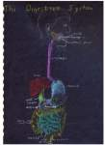
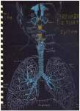
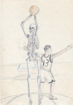
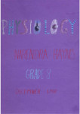

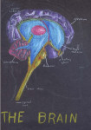
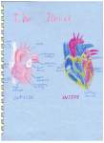
Cover The Skeleton The Respiratory System The Digestive System
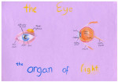
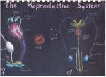
The Heart The Brain The Eye: The Organ of Light The Reproductive Systems
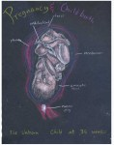
Pregnancy and Childbirth: The Fetus

Physiology: Alexander’s Book
Alexander’s book shows a little of my rethinking of the unit, to which I added a student self-portrait and the use of elaborate cut-outs. Labor intensive–but worth it!
